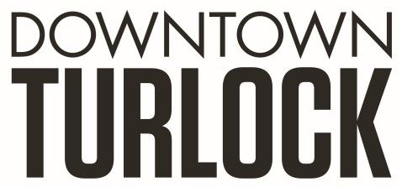
115 S Golden State Blvd, Turlock, CA 95380
Phone: (209) 634-6459
admin@turlockdowntown.com
_________________________________________________________________________________________

TDPOA BOARD REGULAR MEETING AGENDA
Wednesday, July 17, 2019
3:30 PM – 5:00 PM
Chamber of Commerce Board Room
115 South Golden State Blvd. Turlock, CA 95380

Board Members: Michael Camara Marin Krieger Charlene Costa Dan Tallman
Danny Mann Candace Gonsalves Nathan Dabulewicz Randy Woods Jeff Chapman

Executive Director: Molly Amant

Call to Order:

- Public Comment: While participation of all interested parties is welcomed, State Law prohibits the Board from taking action on any item not listed on the Agenda.

- Scheduled Matters:

  - Review and Approval of Minutes from Meeting on June 19, 2019
  - Approval of Financial Report
  - Staff Updates- MA

- Discussion/Action Item:

  - Homeless Discussion
    - Andrew Nosrati Update
    - Stance on Outdoor Emergency Shelter (Tent City)
  - Board Member Resignation
  - Officer Nomination / Vote
  - Update from R.U.F.F.
  - Backpack Drive

- Board Member Comment(s)
Board members may provide a brief report on notable topics of interest. The Brown Act does not allow discussion or action by the Board.

- Announcements and Discussion Items for next Meeting:
- Adjournment

