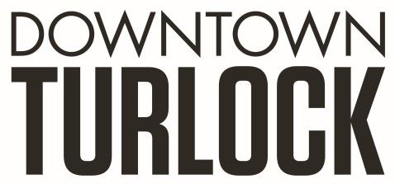
115 S Golden State Blvd,
Turlock, CA 95380
Phone: (209) 634-6459
admin@turlockdowntown.com
director@turlockdowntown.com

_______________________________________________________________________________________________
TDPOA BOARD MEETING AGENDA
Wednesday January 18, 2022
3:30 PM – 5:00 PM
Chamber of Commerce Board Room
115 South Golden State Blvd. Turlock, CA 95380

Zoom Link: https://us02web.zoom.us/j/87686400594

Board Members: Dan Tallman Lori Smith Amy Wilson Danny Mann Devin Hill Alta Fernandes Randy Woods Jeff Chapman

Executive Director: Travis Regalo

Call to Order:

- Public Comment: While participation of all interested parties is welcomed, State Law prohibits the Board from taking action on any item not listed on the Agenda.

- Scheduled Matters:
  - Review and Approval of Minutes from Dec 21, 2022
  - Approval of Financial Report
  - Staff Updates- Travis Regalo
  - Merchant Group Update - Lori Smith / Alta Fernandes

- Discussion/Action Item:
  - Pressure Washing
  - Garden Club
  - Benches
  - Colorscape/Beautification
  - Landscaping Contract
  - Holiday Recap
  - Vacant Building report - Facade quotes
  - Business Owners Budgeting Strategy
  - Banner/Marketing/Promotional Package/Commissions
  - 4th of July
  - Board Member Nominations

- Board Member Comment(s)
Board members may provide a brief report on notable topics of interest. The Brown Act does not allow discussion or action by the Board.

- Announcements and Discussion Items for next Meeting:

- Closed Session

  - Employee review

- Adjournment

