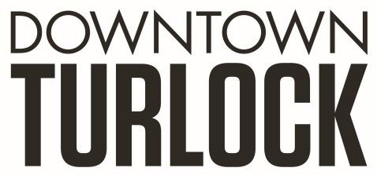
115 S Golden State Blvd, Turlock, CA 95380
Phone: (209) 634-6459
admin@turlockdowntown.com
_________________________________________________________________________________________

TDPOA BOARD REGULAR MEETING AGENDA
Wednesday, May 23, 2018
3:30 PM – 5:00 PM
Chamber of Commerce Board Room
115 S. Golden State Blvd. Turlock, CA 95380

Board Members: Michael Camara Marin Krieger Jerry Powell Dan Tallman
Danny Mann John Jaureguy LeRoy Walker Randy Woods Jeff Chapman

Executive Director: Molly Amant

Call to Order:

- Public Comment: While participation of all interested parties is welcomed, State Law prohibits the Board from taking action on any item not listed on the Agenda.

- Introduction: Special Guests

- Scheduled Matters:

  - Review and Approval of Minutes from Meeting April 18, 2018
  - Approval of Financial Report
  - Merchant Group Updates- MA
  - Staff Updates- MA

- Discussion/Action Item:

  - Bylaws- Board Member Terms
  - Sidewalk Cleaning
  - Downtown Planting
  - 4th of July
  - Downtown Banners

- Closed Session: None

- Board Member Comment(s)
Board members may provide a brief report on notable topics of interest. The Brown Act does not allow discussion or action by the Board.

- Announcements and Discussion Items for next Meeting:

- Adjournment

