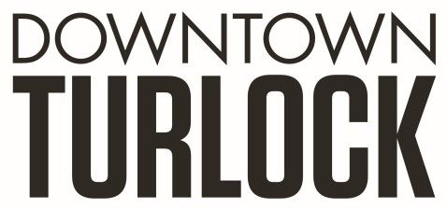
115 S Golden State Blvd,
Turlock, CA 95380
Phone: (209) 634-6459
admin@turlockdowntown.com
director@turlockdowntown.com

_______________________________________________________________________________________________
TDPOA BOARD SPECIAL MEETING WORKSHOP AGENDA
Wednesday, January 4, 2023
3:30 PM – 5:00 PM
Chamber of Commerce Board Room
115 South Golden State Blvd. Turlock, CA 95380

Zoom Link: https://us02web.zoom.us/j/87091891581

Board Members: Dan Tallman Lori Smith Amy Wilson Danny Mann Devin Hill Alta Fernandes Randy Woods Jeff Chapman

Executive Director: Travis Regalo

Call to Order:

- Public Comment: While participation of all interested parties is welcomed, State Law prohibits the Board from taking action on any item not listed on the Agenda.

- Scheduled Matters:
  - PBID Workshop-
The TDPOA board will review and discuss the Property and Business Improvement District and strategies pertaining to, including but not limited to:
- PBID process
- Management plan
- Improvements and Activities
- Assessment Adjustments
- Landscape/Hardscape
- Maintenance
- Standard Operating Procedures

- Discussion/Action Item:
  - Property and Business Improvement District

- Board Member Comment(s)
Board members may provide a brief report on notable topics of interest. The Brown Act does not allow discussion or action by the Board.

- Announcements and Discussion Items for next Meeting:
- Set next workshop date

- Adjournment

